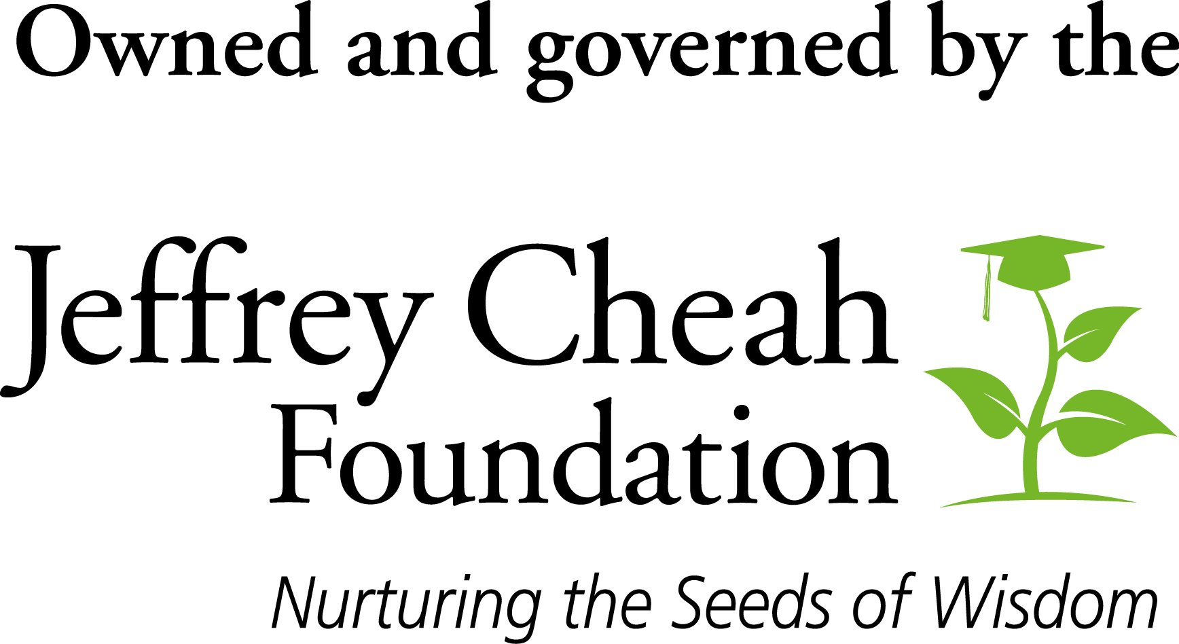

The Jeffrey Cheah Travel Grants for Southeast Asia Studies
at Harvard University

Grant Application Form
APPLICANT’S PARTICULARS (Please complete where applicable)
Full Name (as in passport/IC):
Name of Institution:
Name of Programme/Department:
Office Tel No:
Mobile Tel No:
Email Address:
Research Project Title or Nature of visit
Status of Candidature: | Full time student (Post- secondary/ Undergraduate/ Postgraduate)  Academic staff since ___________  Non-academic staff since _____________
Supervisors/Immediate superior: | 1.  2.

APPLICATION ENDORSEMENT
I endorse this application for a travel grant for__________________________________to undertake a study tour at Harvard University under the Sunway Harvard Initiative.

----------------------------------------- ----------------------------------------------
(Signature of Supervisor/Immediate Superior) (Signature of HOD/Dean)
Name: Name:
Date: Date:
APPLICANT COVER STATEMENT

Section 1: Research Focus/Statement of Purpose

Section 2: Relevance to Sunway Harvard Initiative

Section 3: Expected outcome of Travel Grant

Section 4: Overview of research project (Include Research Framework where applicable)

Section 5: Contacts at Harvard
Please provide names and departments of individuals at Harvard whom you would like to connect/ work with or have made contact with.

No. | Name | Department

Section 6: Academic Referees
Provide contact details of at least two academic referees.
 | Referee #1 | Referee #2
Name:
Academic Relationship:
Name of Institution:
Email Address:
Telephone No.:
* A letter of recommendation must be emailed directly to chooiyeel@sunway.edu.my

Section 7: Duration and Estimated Cost of Visit
Items | USD  1USD = RM4.22 | RM
Return Economy Class Fare
Accommodation
Meal Allowance
Local Traveling
Total
*As per published rate on 27 Feb 2020
Proposed period of travel  (kindly tick one) | Harvard Fall Term (Sept – Mid Dec)  Harvard Spring Term (End Jan – May)
Proposed Length of Stay/Visit

Section 8: Declaration
I, the undersigned, hereby declare that the information provided by me in this form is correct to the best of my knowledge. I authorise the release of information/data listed in this application and supporting documents to appropriate persons within the Harvard University and the Jeffrey Cheah Foundation, in confidence, as part of any selection process for the travel grant. I agree to abide by the conditions, regulations, and rules set out in the Jeffrey Cheah Travel Grants for Southeast Asia Studies, where applicable.

--------------------------------------------------------
(Signature)
Name:
Date:

Please email a pdf copy to: chooiyeel@sunway.edu.my

Or mail /deliver to : Lee Chooi Yee,
Office Manager,
Jeffrey Cheah Institute on Southeast Asia.
No.5 Jalan Universiti,
Bandar Sunway
47500 Selangor Darul Ehsan
Tel No: 03 – 7491 8622 ext 7520

