Paper Code: xxxxx (Will be allotted by organizer)

Title of the paper <Times New Roman(TNR)><Font Size 12><Bold & Center Align>
First Author^{1*}, Second Author², Third Author²
<Times New Roman><Font Size 10><Center Align>
¹ Department/School, University & Address
² Department/School, University & Address
* Corresponding Author (email): xxxxxx@yyy.com

Abstract: The abstract should briefly summarize the main contents of your contribution. Recommended line spacing is 1.0 and font Times new roman using font size 10

Keyword: Maximum 5 keyword separated by semicolon

1.0 Introduction (TNR, Bold, 10pt)
The extended abstracts will be gathered in the proceedings of 1st International Conference on Advanced Materials and Sustainable Energy Technologies (AMSET). In order to have similar format for all extended abstracts of the conference volume, this document gives some recommendations to the authors when elaborating their extended abstract.
The extended abstract should be formatted in A4 format (210 mm x 297 mm) with page margins of 25 mm on the left and right sides and 25 mm on the top and bottom. The maximum allowed size is 2 pages. Pages must not be numbered as the pagination will be done during the edition process for the full preprint volume. The first page must begin with the paper title in capital letters centered. All authors' names and affiliations appear just below the title. The email address is only given for the corresponding author. An abstract and keywords directly follow.
The text should be divided in several sections, e.g. INTRODUCTION, MATERIALS AND METHODS (or MODEL SETUP for numerical modelling papers), RESULTS AND DISCUSSION and CONCLUSION. Sections can be divided in sub-sections with subtitles. The text must be in a single column format. For the body, the text must be single-spaced and justified, using preferably Times New Roman font. Sizes are specified at various locations. It should be structured in paragraphs, new paragraphs begin indented (first line 1.27 cm) without an empty line. The paper should be written in English. SI units should be used.
2.0 Materials and Methods (TNR, Bold, 10pt)

The methodology must be clearly stated and described in sufficient detail or with sufficient references.

3.0 Results and Discussion (TNR Bold, 10pt)
The findings and arguments of the work should be explicitly described and illustrated. Supporting figures, tables and images of the results (no more than two figures and two tables) may be included in the extended abstract. All the tables, images and figures should be centered. Figures and images should be numbered and figure captions should be placed under the figure or image; as for the tables, they should also be numbered and the table captions should be placed at the top. References (if any) of the tables, figures and images should be presented correspondingly next to the figure caption or table caption. All figures and tables should be refereed with the extended abstract text.
3.1 Equations
Equations should be centered and numbered consecutively, as in Eq. [1]. An alternative method is given in Eq. [2] for long sets of equations where only one referencing equation number is wanted.

[1]

where,
[2]
3.2 Tables and figures
Tables and figures should appear in one column of a page and be numbered consecutively. Figures and texts may appear on the same page, and a centered caption should appear directly beneath the figure. It is preferable that figures be mounted in portrait style and figure captions are no longer than two lines. On figures showing graphs, both axes must be clearly labeled (including units if applicable).
Tables should be designed to have a uniform style throughout the paper, following the style shown in Table 1. Table captions should be in 10pt “Time News Roman” italic, centered, and the texts in Table should be set in 10pt “Time News Roman” font.
Table 1. Caption heading for a table should be placed at the top of the table and within table width.
(Use “time news roman” font, size 10pt, No spacing after table title)
 | A | B | C | D
A | Aa | Ab | Ac | Ad
B | Ba | Bb | Bc | Bd
C | Ca | Cb | Cc | Cd
D | Da | Db | Dc | Dd
E | Ea | Eb | Ec | Ed
Authors are advised to prepare their figures in either black and white or color. Please prepare the figures in high resolution (300 dpi) for half-tone illustrations or images. Pictures must be sharp enough otherwise they will be rejected. Figures must be originals, computer-generated or drafted, and placed within the text area where they are discussed. Figure 1 shows one example. Figure captions should be in 10pt “Time News Roman” font, italic, centered. When applicable, the texts in graphs, illustrations or images should be set in 10pt “Time News Roman” font.
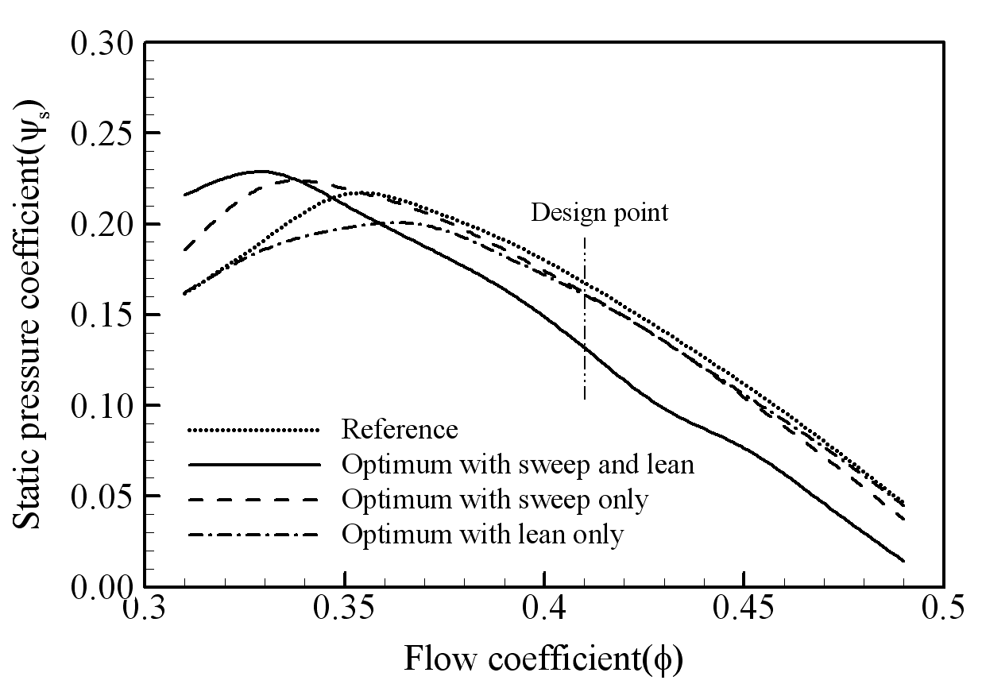
Figure 1. The caption heading for a figure should be placed below the figure and within figure/illustration width. (Use “Time News Roman” font, size 10pt, no spacing between title and figure)

4.0 Conclusion (TNR Bold, 12pt)
Conclusions should include (1) the principles and generalizations inferred from the results, (2) any exceptions to, or problems with these principles and generalizations, (3) theoretical and/or practical implications of the work, and (5) conclusions drawn and recommendations. All reference text should be in 09pt “Time News Roman” font, and follow APA style
Acknowledgement (TNR, Bold, 12pt Left align)
Acknowledgement should be provided before the references.

References (TNR, Bold, 12pt Left align)
- Author, A. A., Author, B. B., & Author, C. C. (Year). Title of article. Title of Journal, volume number (issue number), page range. doi:xxxxxx
- Author, A. A., & Author, B. B. (Year). Title of chapter. In A. Editor & B. Editor (Eds.), Title of book (pp. xx-xx). Publisher. doi:xxxxxx
- Author, A. A. (Year). Title of thesis (Doctoral dissertation or Master's thesis). Name of Institution, Location.
- Author, A. A., Author, B. B., & Author, C. C. (Year, Month Day). Title of article. Title of Magazine, volume number (issue number), page range. doi:xxxxxx
- Author, A. A. (Year, Month Day). Title of article. Title of Newspaper, page range. Retrieved from newspaper homepage URL

